Comments on
EPA’s Proposed New Source Performance Standards for Electric Generating Units: Understanding the Role of the Ocean in Climate Science
Docket No. EPA-HQ-OAR-2013-0495

Submitted by
Carol Anne Clayson, Ph.D.
Senior Scientist, Department of Physical Oceanography
Woods Hole Oceanographic Institution
May 9, 2014

In the Climate Action Plan announced by President Obama in June 2013, the Administration observes that “[c]limate change represents one of our greatest challenges of our time . . . .”1 The Climate Action Plan emphasizes the important role science will play in addressing this challenge in the U.S. and internationally. While the Administration is moving forward with regulations to reduce greenhouse gas emissions to address climate change, the U.S. Environmental Protection Agency (EPA) has
acknowledged that scientific uncertainty remains and has invited comments on the science in its proposed rulemaking to reduce greenhouse gases from electric generating units.2
A significant area of uncertainty in climate science and one of the biggest limitations on our ability to predict the timing, location and impacts of climate change is our limited understanding of ocean processes and their interactions with the atmosphere, land, and ice systems. Any serious effort to address climate change and mitigate its impacts must include support and investment in more ocean research. For example, understanding how much heat and carbon the ocean absorbs is vital to understanding sea level rise and predicting how much, how fast, and where the atmospheric temperature will change.
The global climate is a complex system consisting of interactions between the atmosphere, the ocean, the land surface, snow and ice, and the biosphere. Each of these parts of the climate system is different in composition, structure, and behavior. Predicting this complex system requires sophisticated computer models. However, models can only make calculations based upon our current scientific understanding of how these complex systems function. While the climate models include what is known today about the ocean and its influence on climate, there are still many gaps in our

knowledge. We fill these gaps with our best scientific assumptions, but these gaps and the assumptions we use to fill them are a major reason that there are still significant differences among the various climate models related to projected climate impacts and their timing. What we need are more and better observations – data – that enhance our scientific knowledge and that we can use to improve our models and reduce the uncertainties in our climate forecasts.
These comments explain the scientific importance of the ocean to our climate system, some of the significant gaps in our knowledge, and how filling those gaps would enable us to better address climate change going forward. In short, these gaps in our understanding can only be closed in a timely fashion with significant additional funding. Climate change is one of the greatest challenges facing the world today, and we owe it to ourselves to make sure we get the answers we need to develop informed and effective solutions.

I. The Relationship Between Ocean and Climate

It is often said that the ocean is the flywheel of the Earth’s climate. Just as the flywheel in an engine absorbs and releases energy to stabilize engine speed, the ocean absorbs and releases thermal energy, stabilizing the Earth’s climate. The ocean reacts more slowly than the atmosphere to changes in heat but also stores this heat and releases it over longer time periods. As such, the ocean plays a significant role in moderating the weather and global climate.
The ocean’s ability to store and release heat and carbon dioxide make it a primary driver in long-term weather patterns. The ocean is the world’s largest thermal reservoir, due in part to its extent – the ocean covers 70% of the Earth’s surface. In addition, water has a very high heat capacity – more than 1000 times the heat capacity of the atmosphere. While the atmosphere loses heat relatively quickly over months, the ocean can hold onto heat for decades in the upper-ocean or centuries in the deep ocean.
The ocean is also much more efficient at absorbing solar radiation than land, snow, or ice. When the sun is directly overhead, the ocean can absorb 97% of the incoming solar radiation, while dry soil will absorb roughly 60%. Snow and ice will absorb even less. This difference in absorption, coupled with the larger area the ocean covers in the tropical

regions, means that the ocean absorbs the majority of the solar energy absorbed on Earth. Since the poles absorb much less solar radiation than the equatorial region, there is a surplus of energy in the equatorial region and a deficit in the poles. The ocean carries the heat out of the tropics through the ocean circulation, while the atmospheric circulation continues moving heat from the near-equatorial region to the poles. This uneven heating and consequent transport of heat by the ocean and the atmosphere sets the basic outlines of the Earth’s weather and climate.
The ocean also plays a significant role in global rainfall. Evaporation from the ocean supplies 90% of the water vapor that eventually becomes rain and snow. Roughly 40% of the precipitation that falls over the land originated directly from evaporation over the ocean. The ocean helps to determine the location of clouds and precipitation by influencing the atmospheric motions that move water throughout the global atmosphere. Figure 1 provides an overview of the relationship between the ocean and atmosphere and some of the exchanges between the two.

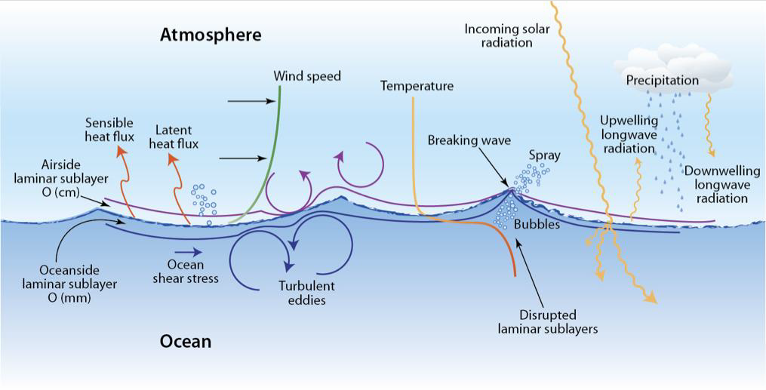

Figure 1. An overview of many of the processes and exchanges occurring at the air-sea interface. Courtesy of Lonny Lippsett, Woods Hole Oceanographic Institution (WHOI).

The ocean is a major driving force behind how air moves around the globe. The exchange of moisture between the ocean and the atmosphere by evaporation provides a source of heat to the atmosphere. This heating occurs in regions of warm water, such as the equatorial region, and masses of warm and buoyant air are formed, causing the air to rise. As the warm air rises, the water vapor in the air condenses, releasing heat to the atmosphere. This heating provides the energy to drive an important feature of the

atmospheric circulation, the cell of air that moves warm air from the tropics to the mid- latitudes. As illustrated in Figure 2, the atmospheric circulation all across the globe is interconnected through these types of rising and sinking motions. These resulting circulation patterns set the main regions of rain and arid conditions across the globe. The resulting winds then drive the ocean currents, which act to redistribute the heat within the ocean, setting the regions of warmer and cooler sea surface temperatures. Sea surface temperatures in turn then help set the atmospheric circulation.
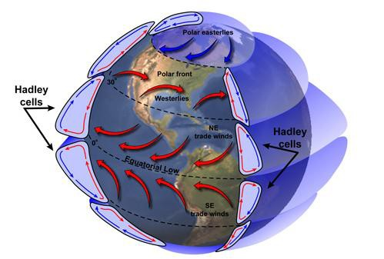

Figure 2. General atmospheric circulation features. From the National Aeronautics and
Space Administration (NASA) Earth Observatory.

The ocean has its own circulation patterns, set in part by the winds that result from the atmospheric circulation patterns. The oceanic circulation is also partially a function of the density structure of the water masses comprising the ocean basins. The density at the surface of the ocean is affected by the amount of freshwater coming in through precipitation and freshwater going out by evaporation. In addition, the density at the surface is affected by the amount of heat coming and going out between the ocean and the atmosphere.
Although each ocean basin has its own circulation, the entire ocean system is connected throughout the surface to the deepest layers (Figure 3). A core feature of this circulation is the formation of deep water at the surface, typically by cooling of the surface water by heat loss to the atmosphere and/or making the surface water so salty through evaporation or by sea ice growth that the density increases to the point that the

water sinks. The movement of heat by the ocean at the surface from the equatorial regions to the poles occurs through this large-scale circulation. A component of this circulation in the North Atlantic basin is called the Atlantic Meridional Overturning Circulation (AMOC), and the surface component of this is the Gulf Stream. The Gulf Stream is of crucial importance in defining the climate of Europe, and for this reason the AMOC is a major ocean process of study for oceanographers.
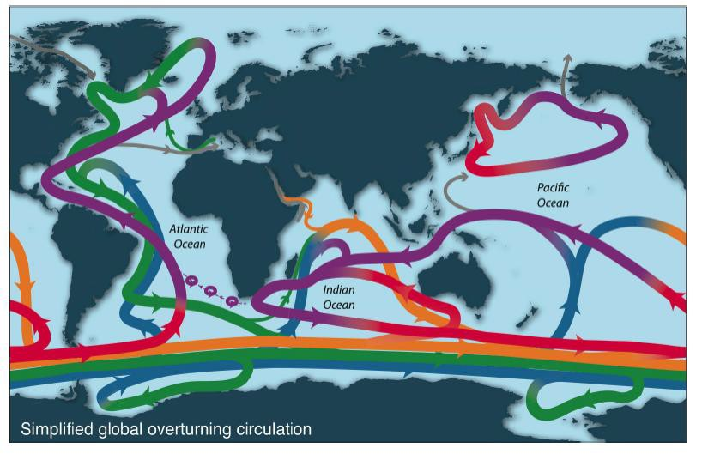

Figure 3. A simplified view of the global ocean circulation. The warmer surface water is shown in purple and red, with colors changing to green and blue as the water sinks and cools.3

In addition, the ocean plays an important role in the storage and release of CO2. The ocean is a large reservoir of carbon. In the case of CO2, there is, on average across the globe, a net uptake of airborne carbon by the ocean. The highest concentration of CO2 in the ocean is in the upper water. The extent to which the deeper ocean’s CO2 concentration can increase is dependent on how much water is mixing between the surface water and the deep water. This is true also of the exchange of heat between the upper ocean and the deep ocean, as the ocean is heated at the surface through absorption of solar radiation. Increases in heat and CO2 in the ocean leads to a reduction in pH and carbonate saturation rate, a process called “ocean acidification”.4

As a result, the ocean has moderated the total CO2 in the atmosphere, with measurements indicating that the atmosphere would have 55 parts per million more CO2 were it not for the uptake of CO2 by the ocean. Roughly half of all the anthropogenic carbon released into the atmosphere between 1800 and 1994 is currently stored in the ocean.5 It should be noted that the uptake of CO2 by the ocean is decreasing,6 possibly due to fact that CO2 solubility in the ocean decreases as temperature increases.

II. The Role of the Ocean in Natural Climate Variability

The ocean profoundly influences natural climate variability – both short-term (over one or two years) and longer term (over decades). A particular feature of our climate system is the ubiquity of naturally recurring cyclical patterns of variability, called oscillations. One of the most commonly-known atmosphere-ocean natural climate events is the El Niño/Southern Oscillation (ENSO). ENSO occurs approximately every two to seven years and typically lasts between nine months and two years. ENSO has two phases, a warm phase, known as El Niño, and a cool phase, known as La Niña. The El Niño phase of this oscillation occurs when warm surface water that typically resides in the tropical western Pacific Ocean shifts towards the Central Pacific concurrent with changes in the trade winds. These year, to two-year, sea-surface temperature shifts, and the resulting atmospheric circulation changes, affect rainfall and temperature patterns across the globe (Figure 4). Even changes in the yearly total global CO2 ocean contents
are correlated with the phases of ENSO.7 There are currently several competing theories

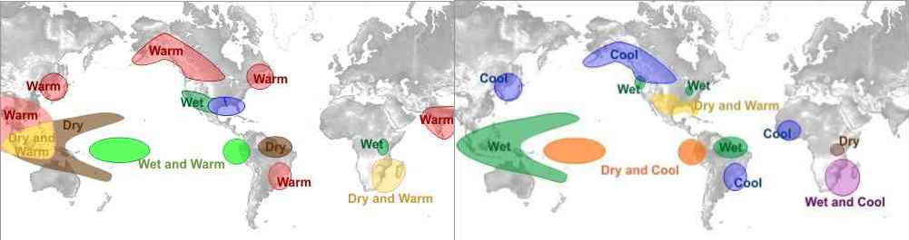as to why ENSO occurs, but there is no scientific consensus on this point, which leads to a general lack of accurate ENSO predictions in the global climate models.

Figure 4. December through February effects of El Nino (top) and the cool phase of ENSO (La Nina) (bottom). From the National Weather Service Online School for Weather.

The impacts of the changes in rainfall and temperature on the U.S. due to the 1982-

1983 El Niño were significant enough that in order to better predict such events a new moored buoy array (the tropical ocean global atmosphere (TOGA) tropical atmosphere ocean (TAO) array) was put into place in the tropical Pacific Ocean beginning in 1984, with the full array completed in 1994. This array, and data from other ocean sensors, can be used to track changes in the sea surface temperatures that can help identify developing El Niño and La Niña events. Due to recent rising temperatures in the central and eastern Pacific, the National Oceanic and Atmospheric Administration (NOAA) is currently predicting the possible development of an El Niño event this year (2014). Because of this possibility NOAA is also predicting that temperatures across the United States will diverge from average conditions. By improving our ability to track sea surface temperature changes in the Pacific Ocean, we have improved forecasters’ ability to predict ENSO events and the related changes in temperature and rainfall. The increased data is also helping to refine our understanding of ENSO, which will help in predictions of ENSO variability over longer time scales.
The coupled ocean-atmosphere ENSO phenomenon also affects the strength of another significant land-atmosphere-ocean coupled weather pattern: the Northern Hemisphere regional monsoons (South Asian, East Asian, West African, and the North American). These monsoons occur annually and together affect 60% of the world’s population. For instance, the amount of rainfall that occurs during a given monsoon season is strongly correlated with both phases of ENSO.8. A warm phase produces less rainfall, and a cool phase produces more rainfall. This rainfall variability directly influences such activities as crop production in India, which can vary by 15 – 20% depending on the strength of the monsoon.9 An important factor in the development of the monsoon regime is the contrast between the land and ocean heat capacity. During summertime, the land heats up more than the ocean, causing a land-ocean temperature contrast that drives the flow from over the ocean across the nearby land mass, in turn
causing the extensive monsoon rainfall.

The ocean is also a driver of longer-term natural climate variability, such as the Pacific Decadal Oscillation (PDO). The PDO is similar to a long-lived ENSO phenomenon, with unusually warm varying with unusually cold sea surface

temperatures.10 Whereas ENSO cycles generally last for less than two years, a single PDO phase may last for decades. Like ENSO, the PDO is associated with changes in temperatures and precipitation, but unlike ENSO the changes are stronger in the North Pacific and North America than in the equatorial Pacific region. Also like the warm phase of ENSO (i.e. El Niño), a warm phase of the PDO is associated with higher sea surface temperatures in the eastern Pacific, which in turn heat the atmosphere. Summer rainfall and droughts11 and winter and spring floods in the U.S.12 are associated with the phases of this oscillation.
The ocean can play a role in more abrupt climate changes as well. Significant changes in climate variability have occasionally occurred in the past over relatively short time scales (called “abrupt climate change”). These changes occur as a threshold or “tipping point” when some aspect of the climate system is reached, and the climate adjusts over decades or even more rapidly.13 An example is the abrupt end to the very cold climate conditions that existed for a millennia up to roughly 12000 years ago (called the Younger Dryas or the “Big Freeze”). This long-term cold climate transitioned from warmer conditions over the timescale of a decade or less and is notable for causing the
extinction of nearly three-quarters of the large mammals in North America.

There are currently a number of hypotheses about the causes of these changes, nearly all of which include the crucial interplay between the atmosphere, sea ice, and the ocean.14 For instance, the abrupt series of climate changes during the last ice age have been linked to large variations in the AMOC, caused by changes in the amount of deep water formation, perhaps as a result of changes in sea ice. These types of abrupt climate changes are of significant concern because their key characteristic is that they may in the
future occur faster than expected or for which we may be planning. They may also trigger more extreme weather events, but this is quite uncertain as our understanding of both extreme events and abrupt climate changes is still relatively limited. In any case, the ocean clearly has a significant influence over short-term and longer-term natural variability in the climate system that affects weather patterns across the globe.

III. Key Uncertainties Still Remain

This section highlights just a few of the many key uncertainties that remain in our understanding of the ocean and its interaction with the atmosphere, land, and ice. These uncertainties significantly affect our ability to understand past and current climate variability and our ability to use this understanding to predict future climate variability.

A. Lack of Data, Scientists and Priority

While much has been learned by oceanographers and climate scientists about the processes in the ocean and their effect on the climate in the last decades, there remains a significant lack of key data. The ocean remains highly under sampled, from the surface exchanges between the ocean and atmosphere all the way down to the deepest parts of the ocean. Many of the processes, and especially those that relate to interactions between the ocean and the atmosphere, are simply not well understood due to both a lack of data and the relatively small number of researchers funded to work in these areas. Similarly, relatively few direct observations exist of the ocean deeper than a mile down, and this hampers our ability to understand how the deep ocean stores and exchanges heat, salt, and carbon with the upper ocean and how it transports these properties around the globe.
It is unsurprising that these observational gaps exist, given the relative difficulty and high cost of getting scientists and instruments to remote ocean regions as compared to land-based measurements. While land-based measurements of the surface and atmosphere can also be difficult due to budget and geopolitical constraints, they are generally easier and cheaper than similar ocean measurements and are therefore more prevalent. Satellite observations of the atmospheric structure from the top to the bottom are also possible. Conversely, satellites can only “see” the surface of the ocean, below which scientifically-based inferences must be made in many cases to relate observed surface properties to deeper ocean aspects such as circulation and temperature structure. And of course the fact that we as humans live mainly on the land means that a great deal of our emphasis has been and will continue to be focused on the atmosphere and climate over the land surface. However, as our knowledge of the climate system has increased, so has our appreciation of the importance of the ocean to the climate system.

Understanding the ocean is critical to meaningfully predict what the future holds for our climate worldwide.

B. Air-Sea Exchanges

Our knowledge is still incomplete about how to relate the relatively easier to make observations of wind speed, humidity, and other components of the lower atmosphere to the actual air-sea exchanges of heat, moisture, momentum, and gasses. These direct exchanges between the ocean and atmosphere are rarely measured. This is especially true under extreme conditions like high wind speeds, including hurricanes, and in difficult to reach locations, such as the Southern Ocean, where very few direct observations of the
air-sea exchanges of heat and moisture have ever been taken.15 Because of this lack of

measurement, open questions still remain about the influence of waves, sea spray, bubbles, and other properties of the air-sea interface on these exchanges. Without better measurements and models of these processes, how the ocean takes up heat, moisture, and carbon and other gasses will remain unknown.
Another difficulty in understanding the relationship between these processes is that the events associated with the exchanges of heat, moisture and carbon between the ocean and atmosphere vary across many time and space scales. For instance, the pattern of rainfall depends on the cloud patterns. Clouds can be individual small cumulus clouds that exist only for minutes to hours, or they can be part of a larger cluster of clouds that cover tens of thousands of miles and are much longer lived. Cloud variability can also be organized across even decadal and ocean basin scales. The ocean response to this wide spectrum of variability is complicated, and we do not yet understand the nature of its response across all of these varying time and space scales, in part because observations of these exchanges across all of these ranges often do not exist.
Cloud variability is a major component of climate change and is significantly influenced by the ocean, but the ocean-atmosphere exchanges that result in cloud formation are not well understood. The ocean surface exchange provides a significant fraction of the aerosols that form the basis in the lower atmosphere for cloud formation, particularly in remote areas of the ocean. Uncertainties in how sea spray is generated by waves limit our understanding of the transfer of heat and momentum between the ocean

and atmosphere, especially in regions of high winds, such as hurricanes. A lack of measurements at high wind speeds and in remote regions like the Southern Ocean limits our ability to accurately model the rate at which aerosols are transferred to the atmosphere, which in turn affects our understanding of cloud variability, and thus affects our climate change predictions. Possible future changes in the water cycle also remain fairly uncertain, in part because of observation uncertainties that limit our understanding of how to connect processes such as ocean evaporation to precipitation.
Similarly, the scientific community lacks a robust understanding of how to estimate the exchange of CO2 between the ocean and atmosphere given the few variables that can be measured and the significant uncertainties surrounding other key variables (e.g. wind speed) that are needed to calculate this exchange. Once heat or CO2 is deposited in the upper ocean, the eventual extent to which the temperature of concentration changes is largely dependent on ocean dynamics and mixing between the upper and lower ocean, processes which themselves are not fully understood. This mixing in the ocean sets the limits of the amount of anthropogenic CO2 that the ocean can uptake over decadal time scales. The importance of the mixing process to the distribution of CO2 in the ocean can be seen in Figure 5 on the next page; the amount of CO2 is clearly not constant across the global ocean. On centennial time scales, basic scientific principles dictate that the ocean CO2 amount will equilibrate with atmosphere CO2, but an open question remains as to the rate at which this ocean uptake will occur, and our understanding of some key processes that control the carbon distributions in the ocean is still quite limited.

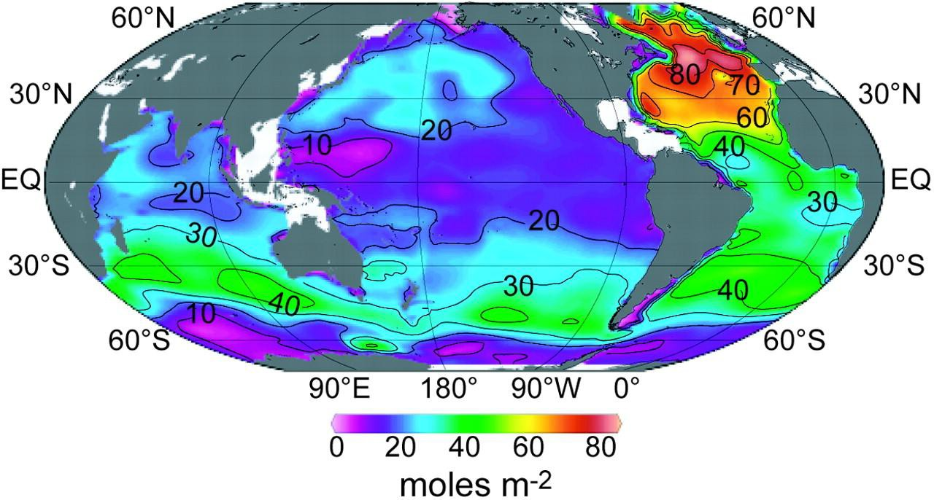
Figure 5. Column inventory of anthropogenic CO2 in the ocean (mol m–2). Regions of higher CO2 inventories (shown in yellow and red) are shown to occur in regions where more deep water is formed from shallow water by mixing or cooling.16

C. Ocean Currents and Circulation

The importance of understanding how the mixing redistributes heat between the upper and the deeper ocean has been underscored in recent years, as the estimated amount of heat being transferred to depths below 700 (meters) m is much higher currently than had been anticipated and is unprecedented in our records. 17 It is hypothesized that this increase in heat transfer from the surface to the lower layers of the ocean may be a key component of the pause in the increase of the Earth’s mean near- surface temperature. 18 Some of this increased downward mixing may be due to a significant strengthening of the Pacific trade winds, resulting in cooler sea surface temperatures. 19 The wind strengthening appears to be related to changes in the atmospheric circulation, possibly associated with changes in the PDO and the Atlantic circulation, although the actual mechanisms by which this might be occurring are currently unknown. None of the current climate models have captured this increase in Pacific trade winds, indicating that our understanding of the relevant processes is incomplete. As with ENSO and many other large-scale variations that are caused by complex and ill-understood interactions between the ocean and the atmosphere, scientists do not yet understand the causes of the PDO. This lack of understanding in turns leads to an inability to accurately reproduce ENSO, PDO, and other types of natural variability in

the climate models, thus making it difficult to accurately predict how this natural variability may change in the future.
Ocean circulation has also changed significantly over time, such as during abrupt climate changes, when the North Atlantic region cooled but the southern Hemisphere warmed. Since the ocean circulation is a key feature of how the ocean stores heat and carbon, and since it is so variable, we need to know not only the present variability but how and why it has changed in the past and how it might change in the future. Some of this variability is due to changes in the heat transport associated with changes in how
much deep water is formed.20 A question that remains is what types of reorganization of

the ocean circulation may happen in the future and how will this impact the atmosphere. For instance, there remain long-standing questions about the importance of the main processes that drive the AMOC as well as whether we can in fact predict changes in the AMOC. Our uncertainties about these processes mean that different types of ocean climate models have very different sensitivities to changes in greenhouse gases and produce sea surface temperature changes that can even differ between increases and decreases over time.

D. Ocean Temperature Trends and Impacts

A key dataset for understanding climate variability is the thermal energy of the ocean at all levels. This information is crucial to expanding our understanding of past, present, and future climate variability. It is difficult to overestimate the importance of this kind of data for understanding the present and predicting the future of human- induced changes. Increases in upper ocean heat content constitute a significant fraction of the heat storage that has occurred over the past 5 decades; one estimate is that the
ocean warming accounts for roughly 90% of the total of Earth’s heat storage.21 As the

ocean heat content increases, sea level rises due to expansion of the ocean water. This is a critical issue, as two-thirds of the world’s largest cities (cities with more than five million people) are at least partially in regions that are less than 30 feet above the current sea level, and issues associated with changes in sea level will profoundly impact this
population.22

Because the ocean and atmosphere exchange heat and moisture, this warming of the upper ocean, which causes a warming in sea surface temperature, tends to be reflected in trends of increasing evaporation and hence precipitation in the global hydrologic cycle, all of which can be and have been observed by evaluating the upper ocean salinity over time.23 These changes in the global hydrologic cycle are not restricted to over-ocean locations. Due to the global nature of the atmospheric circulation, they affect precipitation patterns over the continents as well.
That the upper ocean heat content and sea surface temperature is crucial to weather and climate variability has been underscored by a recent study in which scientists have suggested that the observed increase in temperature over the land has occurred as a result of worldwide warming of the ocean, rather than directly through a direct response to
increased greenhouse gases.24 In this study, model simulations showed that increased sea

surface temperature causes an increase in global humidity, affects the global atmospheric circulation and resultant cloud patterns, and thus changes the inputs of heat through radiation across the ocean and land surface. This clearly highlights the need for understanding the causes of modern sea surface temperature increases, including both the role of anthropogenic changes and variability due to the natural climate system.
Compared to the relatively longer and more global observations of atmospheric temperature changes, however, our time series and global coverage of temperature below the ocean surface is much shorter and much less globally complete, and a number of gaps still remain in our knowledge of heat changes, particularly in the deeper ocean. The first moderately usable ocean temperatures were isolated observations by the HMS Challenger cruises in the 1870’s. Since that time, the upper ocean has warmed substantially on the
global scale.25 There has been an increase in upper ocean heat content with changes in

the upper 700 m, which we can most reliably observe since 1980. There has also been an increase over the upper 2000 m (roughly one mile), which scientists have only been able to fairly reliably measure since 2005. Figure 6 on the next page illustrates these observations and shows that the total amount of energy in both layers in the ocean is clearly increasing in time. It also illustrates the more recent trend in the deeper ocean heat content.

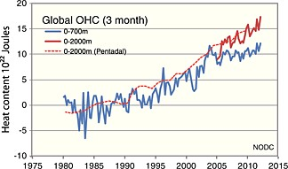

Figure 6: The global ocean heat content (OHC) in 10
22
J from the National

Oceanographic Data Center (NODC) (National Environmental Satellite, Data, and Information Service, NOAA), updated for the last 30 years.26 The solid lines are 3-month rolling averages of the OHC. An estimate of the deeper OHC using a decadal rolling average is shown with the dashed line. The estimate of the deeper OHC is shown on a decadal scale because of the scarcity of measurements. The values shown are differences from an average of the period of 1955 – 2006.27

To put this increase in perspective, the increase in upper ocean heat content over the last thirty years is equivalent to exploding a Hiroshima bomb every second in the ocean for thirty years. For some very deep water masses, such as the Antarctic Bottom Water, it can be shown that the heat uptake between 1980 and 2012 is statistically significant.28
The observations down to 2000 m were made possible when a new observing system called the Argo program achieved a more global reach. Argo is a data collection system consisting of many floats cycling up and down in the water column measuring ocean temperature and salinity. However, significant data gaps remain, particularly below one mile, which is nearly unmeasured.
The importance of ocean temperatures to global climate coupled with the paucity of data regarding ocean temperatures makes understanding the present and predicting the future of human-induced changes a challenging problem for oceanographers. Due to the sparseness of the dataset, many assumptions need to be made about what to use as a climatological reference, and how to include unsampled areas, 29 which creates considerable uncertainty about the amount of ocean heat content change even over the upper mile over the past 50 years. Further, there is no coherent strategy for making
measurements deeper than a mile on the types of spatial and temporal scales that would provide information about how the upper ocean and lower ocean communicate and would

enable us to understand how much heat the ocean is likely to absorb in the future. Autonomous vehicles capable of making measurements down to roughly three miles are available, such as the WHOI Remote Environmental Monitoring Units (REMUS) 6000, but they are few and funded entirely for individual research projects on small scales rather than at a level necessary for coordinated measurements of the entire deeper ocean.
The recent observed weakening in ocean uptake of CO2 could be a result of either human-induced activities or natural variability (or both). A warmer ocean reduces CO2 solubility, but it may also reduce deep water formation, which could also limit mixing of CO2 downwards. Both of these effects would act to weaken ocean uptake of CO2. However, a possible mitigating factor is the Southern Ocean, which might have higher uptake in the future. Specifically, if the current forecasts of strengthening winds are correct, it would lead to more cool water brought from below and an enhancement of CO2 uptake, possibly enough to change the global net uptake to increasing rather than decreasing.30 An important need is for data in such data-poor regions as the Southern Ocean in order to understand the processes that drive changes between the atmosphere and ocean. This understanding could help improve the models and reduce uncertainty over future climate scenarios.
Clearly the uncertainties in our understanding of surface processes, carbon uptake, and ocean circulation are all connected. Most of the processes involved in these connections are not well monitored nor understood, so it is not clear how the ability of the ocean to store anthropogenic carbon will be affected over the next few decades. Over a very long time scale, the ocean will eventually arrive at equilibrium with respect to the atmosphere, but the rate at which this will occur is extremely uncertain. Improved observations of these processes would provide a basis for reducing the uncertainty in our estimates, as would global strategies that provided resources for gathering together and providing observations that may now only be accessible to a few scientists.
Our understanding of the marine ecosystems and marine organisms, and the potential implications of climate changes on these systems, is also subject to significant knowledge gaps, even with the increase in understanding in the past decade. Significant uncertainties still exist about species interactions under ocean acidification,31 and the extent to which natural cycles may influence these interactions. Some of these

uncertainties are due to the wide range of abilities of the global climate models to actually represent some of these natural cycles such as ENSO and the PDO. There is a potential for these cyclical interactions between the ocean and atmosphere to either amplify or diminish the original change, especially between the physics and the biology of the ocean, and these interactions are not well understood or represented in our models. Similar interactions that drive changes in the cycling of carbon through the atmosphere
and ocean are also occurring, with similar uncertainties.32

IV. Need for Ocean Research and Funding for Research

The best way to improve our understanding of the ocean and its crucial impact on the climate system will be through a combination of data collection, data analysis/understanding, and the transfer of this increased understanding to our global climate models. Current funding levels, however, are inadequate to reduce these uncertainties on a timely basis, and are in some cases inadequate to continue even the current rate of progress.
As we improve our understanding of the climate system, we can reduce the uncertainties in our forecasts. This in turn translates to better policy-relevant information on the time scales of proposed changes and improved information on the geographic scope of those changes. An outcome of this improved information is that policy-makers can then more effectively focus limited resources on appropriate mitigation and adaptation strategies.
Funding for many aspects of ocean research has been declining over the last decade. As an example, the Argo drifter program was initiated in FY 2003, with a budget of roughly $9.8 million. This program is one of the successes of 21st century oceanography, with many of the new results that have been discussed here being a product of this greatly enhanced observational capability. As a result, Argo is frequently asked to include enhancements by the larger community, including expansion of coverage, additional sensors, and improved sampling of the near-surface layer.33 However, in nominal dollars (not adjusted for inflation), the U.S. program has received flat funding since FY 2003 (FY 2013 funding was $9.65 million, all from NOAA).34 Adjusting for inflation, funding for the Argo program has actually decreased.

Funding cuts have also severely impacted the TAO buoy array that is essential for our ENSO early-warning system, putting it in even more critical condition. Data is currently available from only 40% of the original array,35 as more than half of the buoys have failed in the past two years. This has occurred because in 2012, as a result of budget cuts, NOAA had to retire the ship that was used for servicing these buoys. Prior to 2012, the total budget for the TAO project was $10-12 million, of which $6 million was budgeted for ship operations. After the ship’s retirement, NOAA has spent roughly $2-3 million to charter boats for servicing these buoys, but this has not been enough to keep the system at
full strength. The NOAA spend plan for FY 2013 was $415 million for research and development (R&D) and $128 million for R&D equipment. It should be noted that NOAA conducts scientific research in areas such as climate, weather, air quality, and ocean and Great Lakes resources, and that the funds listed above are used to support all of these activities, not just ocean research. The level to which the NOAA funding is stretched thin is exemplified by the need to save a few million dollars that would otherwise keep the TAO array at optimal strength.
Of the $7.3 billion allocated for National Science Foundation in the President’s FY

2015 budget, roughly 2% will be available for investment in research on any aspect of the ocean, and of that, only a tiny fraction supports projects directly related to the ocean’s impact on climate change.36 The President’s FY 2015 budget also includes roughly $11.6 billion for R&D at NASA. In the recent past less than 4% of this amount has gone to Earth science research, which covers research on all aspects of the weather and climate system, including the land, atmosphere, and ocean. 37 When one includes the total requests for other scientific R&D, such as that for National Institutes of Health at roughly
$30 billion, the total government allocation for ocean research is under 1% of the government’s total R&D spend, which has been true during the 1980’s and 1990’s as well.38
Our understanding of the ocean is central to our understanding of current and future changes to the Earth’s climate system. The anticipated costs for mitigation and change will be substantial and dwarf the amount of funding currently received by the entire ocean research community. The current funding level is simply not enough to provide the level of information that the public, and the policy makers, need to make informed

decisions. Perhaps the best summation of the current state of affairs was by Senator Mark Begich (D-AK), who in a 2013 hearing on the deep sea challenge facing the United States, asked hypothetically where we would be today if we had spent half as much money exploring the ocean as we have spent exploring space. The actual answer to this question is unknowable, but it seems safe to say that our understanding, observations, and models of the ocean and its interaction with the climate system would be much less uncertain.

V. Conclusion

The ocean is one of the primary forces driving the global climate. It is the world’s largest thermal reservoir, supplies the vast majority of the water vapor that becomes precipitation (rain and snow), and absorbs a large fraction of the CO2 that is being added to the atmosphere. As the ocean moves heat, it drives the atmospheric circulation and helps define global weather patterns on time scales from minutes to decades. This information is not new. NASA notes that “the key to understanding global climate change is inextricably linked to the ocean.” 39 Thus, understanding, predicting and responding to climate change requires an understanding of the ocean forces that impact
climate. Our knowledge of the ocean has grown substantially in recent decades. With this increase in knowledge has also come an increase in our understanding of just how many aspects of the ocean of which we are still relatively ignorant. There are substantial gaps in our knowledge that creates significant uncertainties about the time scales, location and nature of climate change. Our current climate models and model results are only as good as the information we put in them. Responding to climate change will require our nation to marshal significant resources, both at home and abroad. To ensure we make the most of those resources and use them effectively, we need to fill the significant gaps in our knowledge and develop better information. Doing so requires research and funding for that research.
The President’s 2013 Climate Action Plan acknowledges that “[s]cientific data and insights are essential to help government officials, communities, and businesses better understand and manage the risks associated with climate change.”40 However, because the ocean and climate are “inextricably linked,” the Administration cannot properly

understand and manage those risks without funding and actively pursuing a better understanding of the ocean and its impacts on climate change.
End Notes

1 The President’s Climate Action Plan, June 2013 at 5.

2 EPA, “Standards of Performance for Greenhouse Gas emissions from New Stationary
Sources: Electric Utility Generating Units,” 79 Federal Register 1430, 1440 (Jan 8,
2014).

3 Talley, L.D. 2013. Closure of the global overturning circulation through the Indian, Pacific, and Southern Oceans: Schematics and transports. Oceanography 26(1):80–97, http://dx.doi.org/10.5670/oceanog.2013.07.

4 Doney, S. C., 2010: The growing human footprint on coastal and open-ocean biogeochemistry. Science, 328, 1512-1516.

5 C. L. Sabine et al., 2004: The oceanic sink for anthropogenic CO2. Science, 305, 367.

6 Bates, N. R., Y. M. Astor, M. J. Church, K. Currie, J. E. Dore, M. Gonzalez-Davila, L. Lorenzoni, F. Muller-Karger, J. Olafsson, and J. M. Santana-Casiano, 2014. A time-series view of changing ocean chemistry due to ocean uptake of anthropogenic CO2 and ocean acidification. Oceanography, 27, 126-141.

7 Khatiwala, S., T. Tanhua, S. Mikaloff Fletcher, M. Gerber, S. C. Doney, H. D. Graven, N. Gruber, G. A. McKinley, A. Murata, A. F. Rios, and C. L. Sabine, 2013: Global ocean storage of anthropogenic carbon. Biogeosciences, 10, 2169-2191.

8 Wang, B., J. Liu, H.-J. Kim, P. J. Webster, S.-Y. Yim, and B. Xiang, 2013: Northern Hemisphere summer monsoon intensified by mega-El Nino/Southern Oscillation and Atlantic multidecadal oscillation. Proc. Natl. Acad. Sci., 110(14), 5347-5352.

9 Webster, P. J. et al., 1998: Monsoons: Processes, predictability and the prospects for prediction. J. Geophys. Res., 103, 14451-14510.

10 Zhang, Y., J.M. Wallace, D.S. Battisti, 1997: ENSO-like interdecadal variability: 1900-
93. J. Climate, 10, 1004-1020.

11 Nigam, S., M. Barlow, and E. H. Berbery, 1999: Analysis Links Pacific Decadal Variability to Drought and Streamflow in the United States. EOS, Transactions, American Geophysical Union, Vol 80, No. 51, Dec 21 1999.

12 Hamlet, A. F. and D. P. Lettenmaier, 2007: Effects of 20th century warming and climate variability on flood risk in the western U.S. Water Resour. Res., 43, 1944-1973.

13 Abrupt Impacts of Climate Change: Anticipating Surprises. National Research Council. Washington: National Academies Press, Dec. 2013, 222p.

14 Drijfhout, S. S., Gleeson, E., Dijkstra, H.A. and Livina, A., 2013: A spontaneous, abrupt climate change event in the EC-Earth climate model. Proceedings of the National Academy of Sciences. doi:10.1073/pnas.1304912110.

15 Gille, S., M. A. Bourassa, and C. A. Clayson, 2010. Surface fluxes: Challenges for high latitudes. Eos, 91, (35), 307.

16 C. L. Sabine et al., 2004: The oceanic sink for anthropogenic CO2. Science, 305, 367.

17 Balmaseda, M. A., K. E. Trenberth, and E. Källén, 2013: Distinctive climate signals in reanalysis of global ocean heat content, Geophys. Res. Lett., 40, 1754–1759, doi:10.1002/grl.50382.

18 Guemas, V., F. J. Doblas-Reyes, I. Andreu-Burillo and M. Asif, 2013: Retrospective prediction of the global warming slowdown in the past decade. Nature Climate Change,
3, 649-653.

19 England, M. H., S. McGregor, P. Spence, G. A. Meehl, A. Timmerman, W. Cai, A. S. Gupta, M. J. McPhaden, A. Purich and A. Santoso, 2014: Recent intensification of wind- driven circulation in the Pacific and the ongoing warming hiatus. Nature Climate Change, 4, 222 -227.

20 Broecker, W. S., 1998: Paleocean circulation during the Last Deglaciation: A bipolar seesaw? Paleoceanography 13, 119–121.

21 Church, J. A., N. J. White, L. F. Konikow, C. M. Domingues, J. G. Cogley, E. Rignot, J. M. Gregory, M. R. van den Broeke, A. J. Monaghan, and I. Velicogna, 2011: Revisiting the Earth's sea-level and energy budgets from 1961 to 2008, Geophys. Res. Lett., 38, L18601, doi:10.1029/2011GL048794.

22 McGranahan, G., D. Balk, and B. Anderson, 2007: The rising tide: assessing the risks of climate change and human settlements in low elevation coastal zones. Environment and Urbanization, 19, 17-37.

23 Durack, P. J. and S. E. Wijffels, 2010: Fifty-Year Trends in Global Ocean Salinities and Their Relationship to Broad-Scale Warming. J. Climate, 23, 4342–4362.

24 Compo, G. P., and P. D. Sardeshmukh, 2009. Oceanic influences on recent continental warming. Climate Dynamics, 32, 333-342.

25 Roemmich, J., J. Gilson, and W. J. Gould, 2010: 135 years of global ocean warming between the Challenger expedition and the Argo Programme. Nature Climate Change, 2,
425-428.

26 Levitus, S., J. I. Antonov, T. P. Boyer, O. K. Baranova, H. E. Garcia, R. A. Locarnini, A. V. Mishonov, J. R. Reagan, D. Seidov, E. S. Yarosh and M. M. Zweng, 2012: World

ocean heat content and thermosteric sea level change (0 – 2000 m), 1955-2010. Geophys. Res. Lett., 39, L10603, doi:10.1029/2012GL051106.

27 Abraham, J. P., et al., 2013: A review of global ocean temperature observations: Implications for ocean heat content estimates and climate change, Rev. Geophys., 51,
450–483, doi:10.1002/rog.20022.

28 Purkey, S. G., and G. C. Johnson, 2013: Antarctic Bottom Water Warming and Freshening: Contributions to Sea Level Rise, Ocean Freshwater Budgets, and Global Heat Gain. J. Climate, 26, 6105–6122.

29 Lyman, J. M. and G. C. Johnson, 2014: Estimating global ocean heat content changes in the upper 1800 m since 1950 and the influence of climatology choice. J. Climate, 27,
1946-1958.

30 Doney, S. C., 2010: The growing human footprint on coastal and open-ocean biogeochemistry. Science, 328, 1512-1516.

31 Godbold, J. A. and P. Calosi, 2013: Ocean acidification and climate change: advances in ecology and evolution. Phil. Trans. R. Soc., B2013, 368, 20120448.

32 Wanninkhof, R., G.-H. Park, T. Takahashi, C. Sweeney, R. Feely, Y. Nojiri, N. Gruber, S. C. Doney, G. A. McKinley, A. Lenton, C. Le Quere, C. Heinze, J. Schwinger, H. Graven, and S. Khatiwala, 2013: Global ocean carbon uptake: magnitude, variability and trends. Biogeosciences, 10, 1983-2000.

33 14th Argo Data Management Meeting Report.

34 S. Piotrowicz, personal communication, 2014.

35 Tollefson, J., 2014: El Nino monitoring system in failure mode. Nature News, doi:10.1038nature.2014.14582.

36 National Science Foundation, “NSF Congressional Highlight: Congress Completes
Action on FY 2013 Appropriations,” fact sheet, April 9, 2013.

37 http://www.nasa.gov/pdf/632679main_NASA_FY13_Budget_Science-Earth-Science-
508.pdf.

38 Global Ocean Science: Towards an integrated Approach. National Research Council
Ocean Studies Board. National Academies Press, Washington, DC., 1999.

39 NASA, Climate Variability, http://science.nasa.gov/earth-science/oceanography/ocean- earth-system/climate-variability/.

40 The President’s Climate Action Plan, June 2013 at 16.

